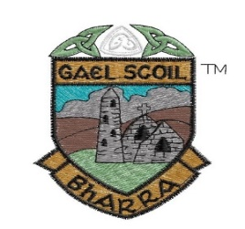
Gaelscoil Bharra
Ascal an Fhasaigh
Cabrach
Báile Áth Cliath 7
D07CF72
teil: (01) 8684827 email:oifig@gaelscoilbharra.net
Foirm Iarratais ( Application Form)
Ainm an Pháiste:________________________________
Dáta Breithe( D.O.B):_____________________________
Uimhir p.p.s :____________________________________
Scoil/ Naíonra ar freastal an dalta roimhe seo? ( Previous nursery school):__________________________________________
Ainm na dTuismitheoirí ( Parents names): _________________________________________________
_________________________________________________
Seoladh roimhphoist / Email:________________________
Seoladh ( address):_________________________________
__________________________________________________
Uimhir Guthán ( telephone number):__________________
Dáta:_____________________________________________
Líon isteach agus cuir chuig Seán Ó Donaile, Príomhoide, ag an seoladh thuas.
Complete and forward to Seán Ó Donaile, Principal, by email or post.

